Brief Biography

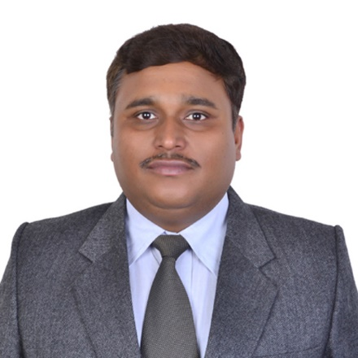
Dr. Brajesh Kumar Kaushik (SM'13) received Doctorate of Philosophy (Ph.D.) in 2007 from Indian Institute of Technology, Roorkee, India. He joined Department of Electronics and Communication Engineering, Indian Institute of Technology, Roorkee, as Assistant Professor in December 2009; promoted to Associate Professor in April 2014; and since Aug 2020 he has been serving as full Professor. He had been Visiting Professor at TU-Dortmund, Germany in 2017; McGill University, Canada in 2018 and Liaocheng University, China in 2018. He is currently serving as Visiting Lecturer of SPIE society to deliver lectures in the area of Spintronics and Optics at SPIE chapters located across the world. He regularly serves as General Chair, Technical Chair, and Keynote Speaker of reputed international and national conferences. He also served as Chairman and Vice Chairman of IEEE Roorkee sub-section. Dr. Kaushik is a Senior Member of IEEE and member of many expert committees constituted by government and non-government organizations. He is currently serving as Distinguished Lecturer (DL) of IEEE Electron Devices Society (EDS) to offer EDS Chapters with quality lectures in his research domain. He is an Editor of IEEE Transactions on Electron Devices; Associate Editor of IEEE Sensors Journal; Associate Editor of IET Circuits, Devices & Systems; Editor of Microelectronics Journal, Elsevier; Editorial Board member of Journal of Engineering, Design and Technology, Emerald and Circuit World, Emerald. He is among top 2% scientists in world as per Stanford University report of 2019. He is currently serving as member of two technical committees namely, Spintronics (TC-5), and Quantum Computing, Neuromorphic Computing and Unconventional Computing (TC-16) of IEEE Nanotechnology Council. He is also Regional coordinator (R10) of IEEE Nanotechnology Council Chapters. He has 12 books to his credit published by reputed publishers such as CRC Press, Springer, Artech and Elsevier. One his books, titled “Nanoscale Devices: Physics, Modeling, and Their Application”, CRC Press won 2018 Outstanding Book and Digital Product Awards in the Reference/Monograph Category from Taylor and Francis Group. He has been offered with fellowships and awards from DAAD, Shastri Indo Canadian Institute (SICI), ASEM Duo, United States-India Educational Foundation (Fulbright-Nehru Academic and Professional Excellence). His research interests are in the areas of high-speed interconnects, carbon nanotube-based designs, organic electronics, device circuit co-design, optics & photonics-based devices, image processing, spintronics-based devices, circuits and computing.

