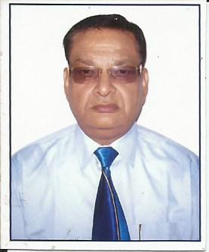
Brief Profile: Dr. Anil Kumar
 | Personal Information
 | Name | Dr. Anil Kumar  s/o Late Shri. S. S. Srivastava
2 | Date of Birth | June 15, 1955
3 | Current Designation | Associate Professor
4 | Department & Institute | Department of Mechanical & Industrial Engg.  I.I.T. Roorkee, ROORKEE-247667 (UK) INDIA
5 | Contact E-mail & Phone No. | anilkfme@iitr.ac.in ; anilkrsri@gmail.com  +911332-285696(O); +91332-285288(R);  +919690252504(M)
6 | Contact Address | B-3, Hill View Apartments, I.I.T. Roorkee, ROORKEE-247667(UK), India
7 | Date of Joining Institute | Dec.07, 1978.; Employee Code : 100103
6 | Experience | Teaching: 37 Years ; Research : 32 years
7 | Academic Qualification | B.Tech (Mech); M.E.(Mech) ; Ph.D (Mech)
8 | Area of Specialization | Heat Transfer; Solar energy
9 | Area of Interest | Refrigeration & Air Conditioning; Thermodynamics; Hydraulic Machines; Cold Preservation of Food
10 | Strengths | Willingness to always learn, adaptability, Reliability, Honesty and strong work ethics
 | Academic Achivements
11 | Published research papers Journals :0 8 Conferences: 09
12 | Ph.d Guided | one
13 | M.tech Disertations | Seventeen
14 | Administrative positions held | Director, OP Jindal Institute of Technology, Raigarh (CG), For Two years 2009-2011; Warden for 5 yrs. and Associate NCC Officer(ANO) for 20 yrs.(1989 To 2009) in the rank of Captain
15 | Consultancy/Sponcered Project | Experimental Studies of Heat transfer Rates during Forced convection Condensation and Evaporation of R134a; R- 152a and R-142b in Horizontal Tubes' "Council of Scientific & Industrial Research" New Delhi for amount of Rs. 13 lacs - 1999
16 | Refrences | 1. Dr. S. C . Sharma, Professor, Dept. of Mech. & Ind. Engg., I.I.T. Roorkee, ROORKEE-247667(UK)  +911332-285603(o) +911332- 285289(R)
2. Dr. Dinesh Kumar, Professor, Dept. of Mech. & Ind. Engg., I.I.T. Roorkee, ROORKEE-247667(UK)
+911332-285670(O) +911332-285309(R)

(Anil Kumar)

